**Microsoft Project 2016: Tutorial 2**

**Refining a Project Plan**

Please make sure to complete Tutorial 1 before starting this tutorial.

**1. Editing tasks**

Editing the list of tasks in a project is relatively intuitive. Task names and durations can easily be changed simply by left-clicking (twice) in the appropriate cell.

A task can be deleted by right-clicking anywhere within the row associated with that task and selecting Delete Task.

A task can be added immediately before an existing task by right-clicking the task and selecting Insert Task.

**2. Practice**

Open the “SimpleSoftwareProject” project that you created for Tutorial 1. Using the techniques described above (or any other technique you might already know or can figure out), make the following changes to the list of tasks – this will require you to edit task names and durations, as well as delete and add tasks:

|  |  |
| --- | --- |
| **Task name** | **Duration** |
| Design admin software | 3 days |
| Design user software | 2 days |
| Implement admin software | 3 days |
| Implement user software | 7 days |
| Test admin software | 1 days |
| Test user software | 2 days |
| Deploy system | 2 days |

Your project should now look something like:

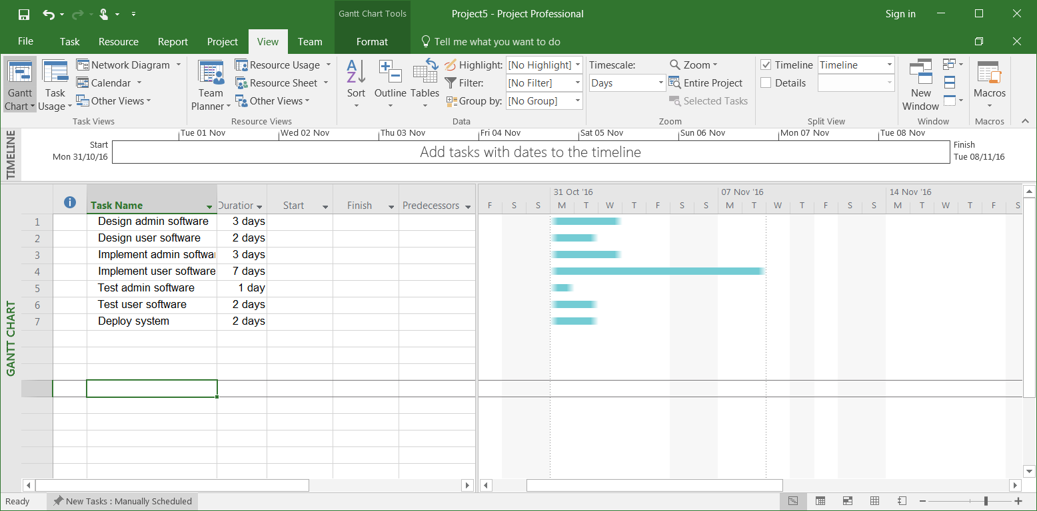

**3. Creating milestones**

Milestones are specific points in a project timeline. They are used as major progress points to manage project success and stakeholder expectations. A milestone can be thought of as a task of zero duration. A milestone is usually placed where there is a logical conclusion of a phase of work, or at deadlines imposed by the project plan

We’re going to create a milestone that marks the end of the design phase of the “SimpleSoftwareProject”. To do this, click the name of the task that immediately follows the point at which you want the milestone to appear – in this case, the task to click is “Implement admin software”. Now invoke the Insert Milestone command – switch to Task tab and from the Insert group select Milestone. MS Project creates a new task called <New Milestone> and assigns it a zero-day duration. Change its name to “MS1: Design Stage Complete”:

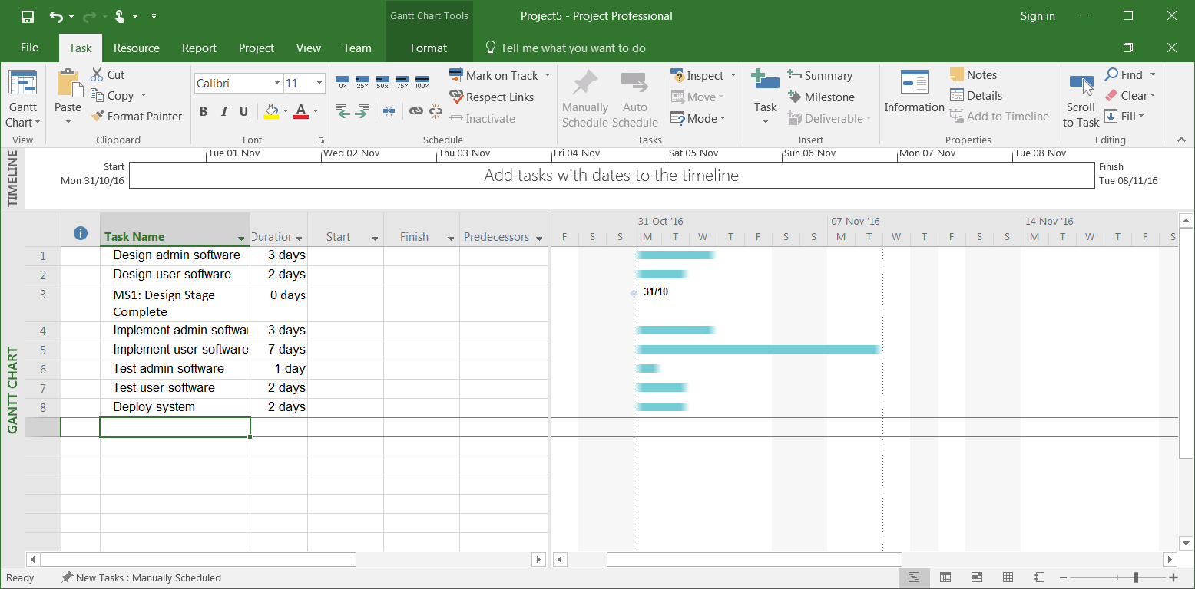

You can also create a milestone by converting an existing task – simply change its duration to “0 days” (or whatever unit of time you happen to be using) and give it an appropriate name.

**4. Creating summary tasks**

For large projects, there can be very many tasks making up the schedule. It can sometimes be useful to group a series of related tasks into what is called a Summary Task. The duration of a summary task is from the start of the first to start sub task and finishes at the end of the last to end subtask.

Let’s create a summary task “Implementation”. To do this, first select the names of task 4 and task 5 (i.e. “Implement admin software” and “Implement user software”). To do this simply switch to Task tab and from the Insert group select Summary. Change the name of the Summary Task to “Implement”:

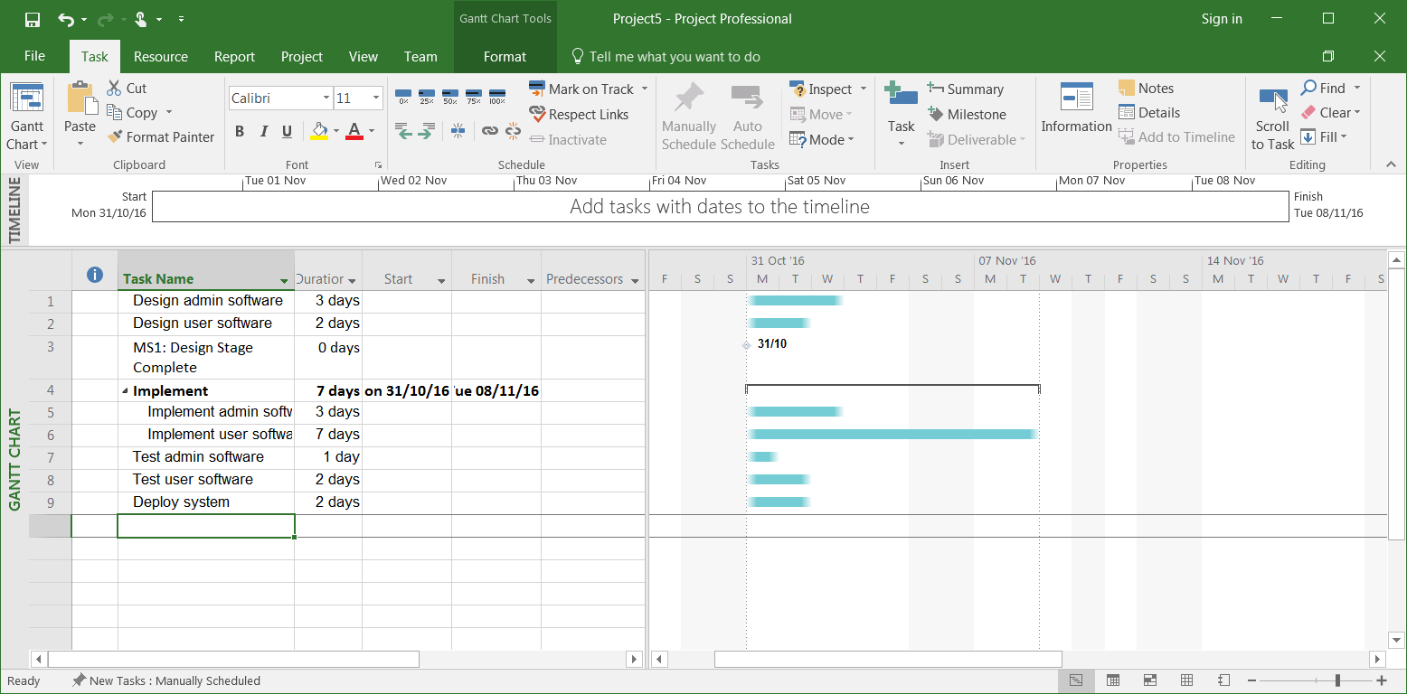

**5. Practice**

Add the following milestones and summary tasks to the “SimpleSoftwareProject”:

MS2: Implementation Stage Complete

MS3: Testing Stage Complete

Design (summary task)

Test (summary task)

You should end up with:

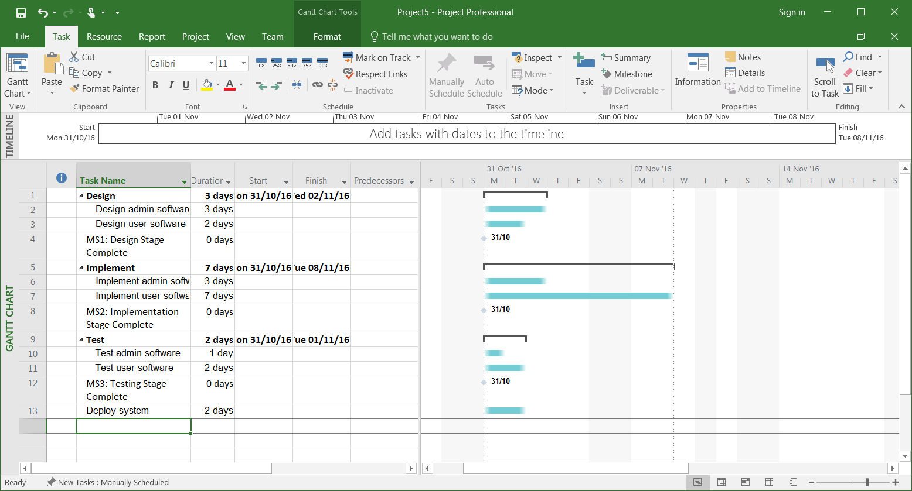

NOTE – the convention used in this tutorial is to include a milestone to mark the end of each summary task. You do not have to adopt this convention, but it represents a clear approach to organising a project.

Save your project, you will need it again.

**6. Practice**

Open the “BuildRestaurant” project. Update it so that it contains the following milestones and summary tasks:

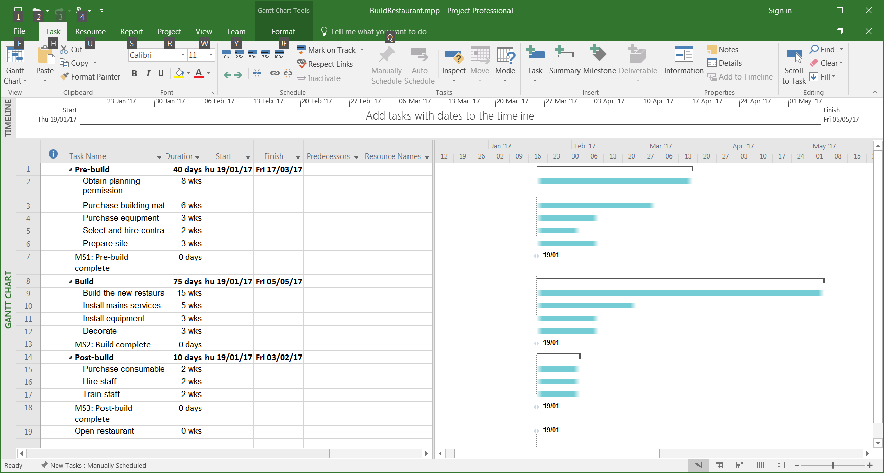

Save your project, you will need it again.